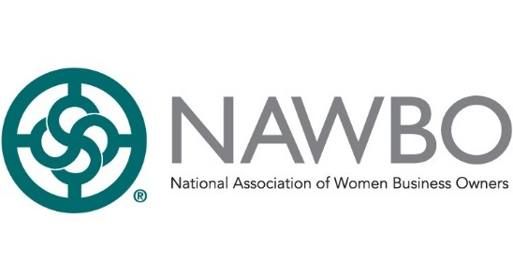

Dear Senator [XXXXXXXX],

The National Association of Women Business Owners (NAWBO) and all our local chapters across the country implores Congress to include organizational non-profits in the next stimulus package. Non-profit member organizations, 501(c)(6) organizations, are left out of the most recent legislation, meaning numerous organizations like NAWBO will not receive any relief during this time of crisis.

If you don’t include organizations likes ours in the stimulus, it will set back women business owners decades. Women business owners rely on resources provided by groups like NAWBO to receive continuing education, tools to scale their businesses, and networking opportunities. Without any relief, these companies will close, and our economy will suffer.

NAWBO started back in 1975 as a women’s advocacy organization because women could not join chambers of commerce. Today, we represent the fastest growing economic sector in the country, employing 9.4 million people and generating $1.6 trillion in revenue. We want to continue to be a resource to our communities.

During this pandemic, even while we face our own challenges, NAWBO National and our chapters have stepped up our efforts to connect and support women businesses owners around the nation through:
- Virtual programming to provide ideas and inspiration (webinars, video chats and more).
- Resource center to give women entrepreneurs the most up-to-date information and resources.
- Advocacy page with updates on how NAWBO is the voice of women and small business owners during this time.
We have also opened up these normally member exclusive opportunities to the public at no cost to ensure the fastest growing economic sector we represent continues to thrive.

Please help us keep our communities strong.

Sincerely,

XXXX XXXXXX
[XXXXX] Chapter Member

